**ASSIGNMENT 1 - DATA ANALYTICS WITH TABLEAU**

**1. BAR CHART**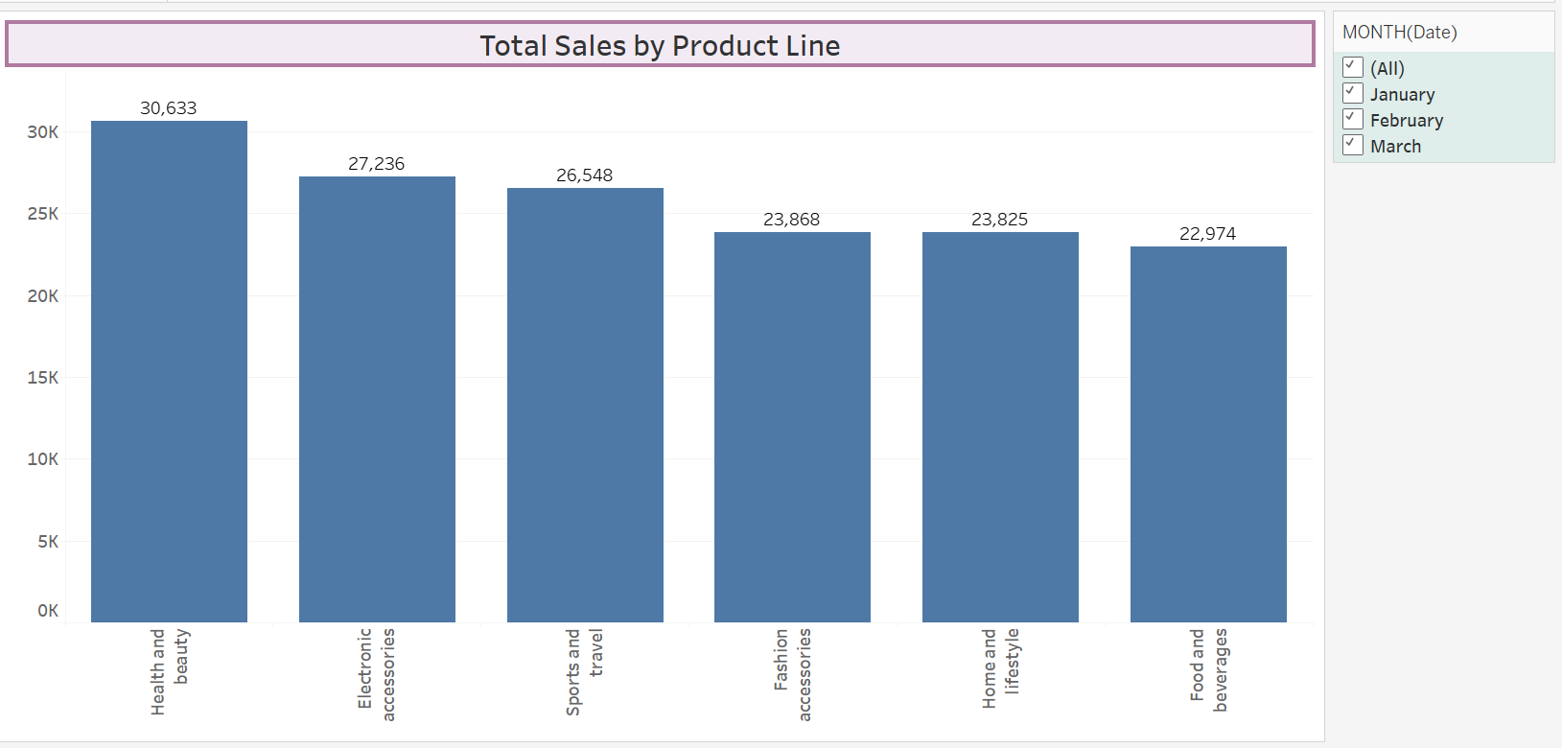

**2.PIE CHART**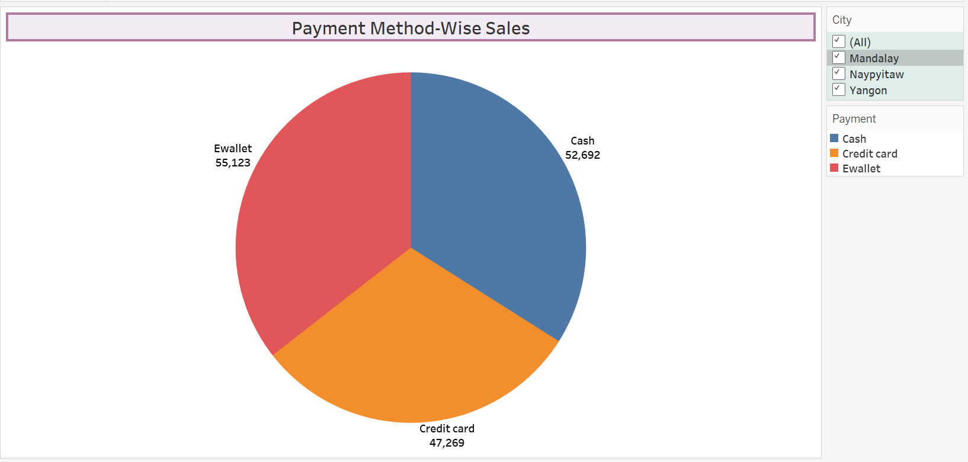

**3.STACKED-BAR CHART**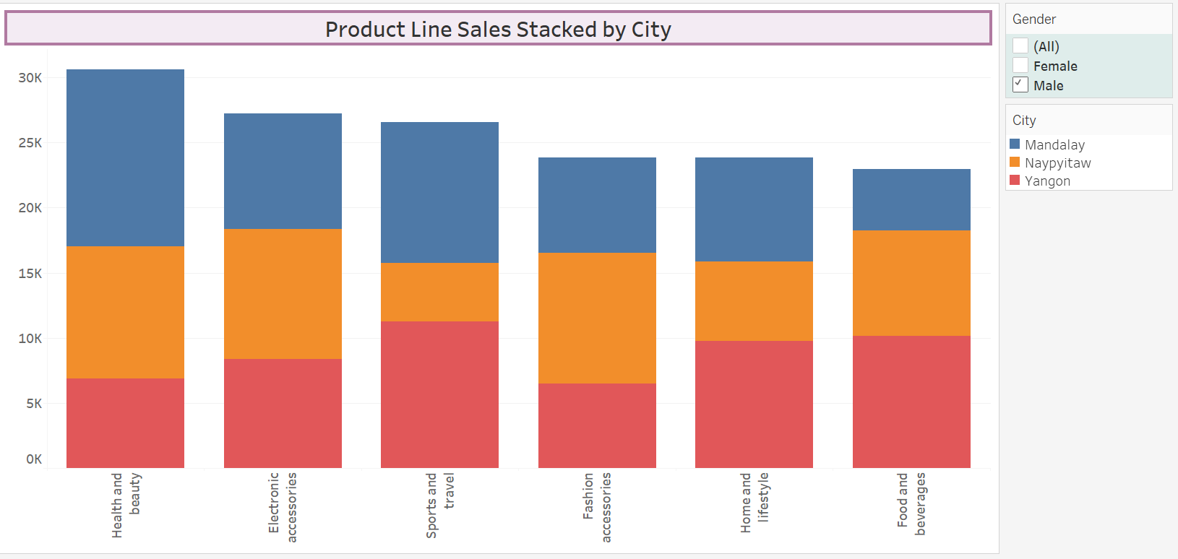

**4. Line chart**

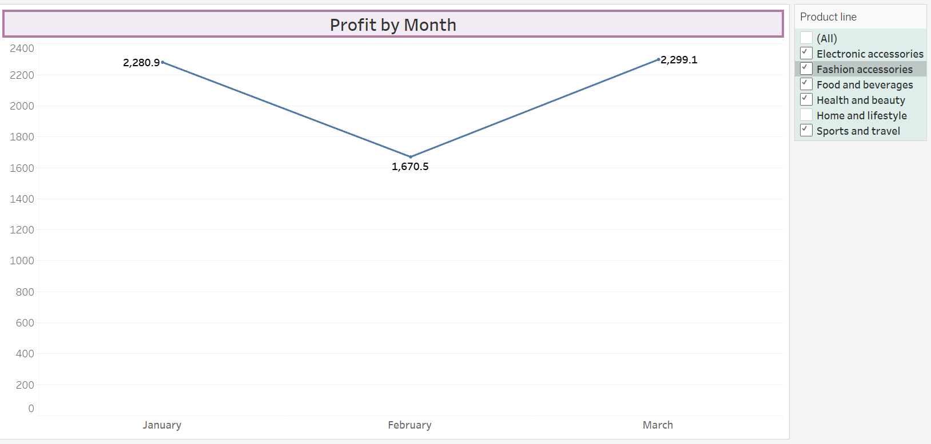

**5.Bubble Chart**

